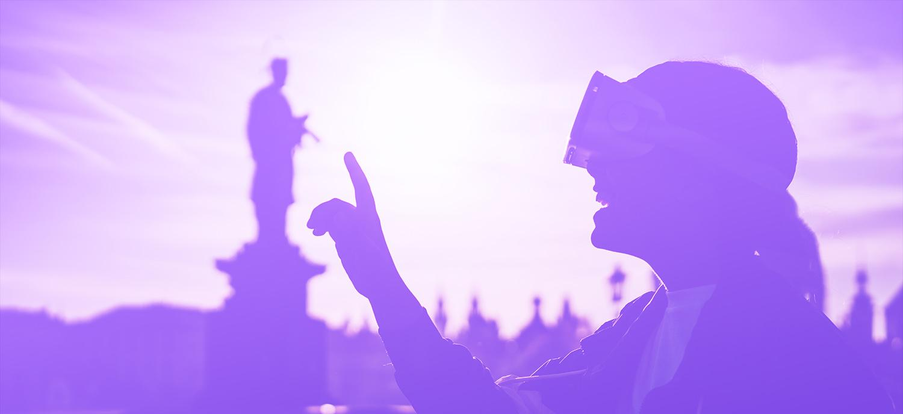
Pack your bags, we’re going on a virtual field trip.
IMEX[cursions] from the IMEX Lab offer a growing set of destinations where students can “travel” without leaving their home, the library or the classroom. Each of these experiences focuses on a particular country and aims to explore its culture, environment, cuisine, history and more.

By leveraging 360º Video, Augmented Reality and Virtual Reality, each field trip will take viewers to the far corners of the globe, allowing for up-close and hands-on discovery of other cultures – their historical landmarks, cultural traditions, favorite cuisines and much more.

Activities

Pre-flight: Select a Destination + Set Expectations

You will be paired up with a partner. Together, choose one of the IMEX[cursions], preferably one that focuses on a country with which you both have not lived in or traveled to.

In your Zoom breakout room, ask each other the following questions:

- What do you know about this country? What would you like to learn more about by way of this virtual visit?
- From what sources have your ideas about this country - or its region more broadly - been derived? What influence has this had on how you imagine life in the country to be?

On the Ground: Your Observations
- Pick at least one video from each of the main categories (examples include Traditions & Culture, Nature & Environment, etc);
- watch these videos in your browser, on your phone or by way of a headset (if you have one);
- select at least one of the related 3D models and identify in your notes how it fits with the content category;
- make notes based on the See, Think, Wonder model (attached);
- compare notes with your partner in your Zoom breakout room - what did they see, what did they think, what has it left them wondering?

Souvenirs: Take-aways
Report back to the main Zoom room when you have completed your observations and talked with your partner. In the large group, participants will reflect on their “journeys”, specifically thinking about:
- What was surprising to you?
- What would you like to learn more about?
- Which of the videos that you viewed did you find most intriguing, and why?
- How might you leverage this content to teach others about another country?

See Think Wonder Model

What do you SEE?
Describe what you observe

What do you THINK?
During experience, explain what you are thinking

What do you WONDER?
During experience, what are the questions that come to mind

